**CHAPTER – 6**

**TESTING**

### Testing Methods

There are different models of testing. On the basis of testing methods there are two types of testing:

1. **Black-box testing**
2. **White-box testing**

Black-box tests are used to demonstrate that software function are operationally, that input is properly accepted and output is correctly produced, and that integrity of external information is maintained.

White-box tests are used to examine the procedural details. It checks the logical paths by test case. It can also checks the conditions, loops used in the software coding. It checks that loops are working correctly on defined boundary value.

* + 1. **WHITE-BOX TESTING**

White-box testing sometimes called glass-box testing, is a test case design method that users the control structure of the procedural design to drive the test case. Always we are thinking that there is no necessary to execute or checks the loops and conditions. And so large number of errors is uncovered. With using white-box testing methods, we have checked that,

* + - * All independent paths within a function have been executed at least once.
      * All logical decisions on their true and false side.
      * All loops working correctly at their boundary values and within their specified conditions.

In our coding we test that all the loops works truly in each module. The one technique of white-box testing is basis path testing. It contains two parts, one is flow graph notation and the second is cyclometer complexity. In flow graph notation we are checking logical control of flow. By using cyclometer complexity we find complexity of our project structure.

* + 1. **BLACK-BOX TESTING**

The technique of testing without having any knowledge of the interior workings of the application is Black Box testing. The tester is oblivious to the system architecture and does not have access to the source code. Typically, when performing a black box test, a tester will interact with the system's user interface by providing inputs and examining outputs without knowing how and where the inputs are worked upon.

**We used following problems in our coding to find errors in the following categories:**

* + - * Incorrect or missing function.
      * Interface errors.
      * Error in database.
      * Performance errors.
      * Initialization and termination errors.

Unlike white-box testing, which is performed earlier in the testing process, black-box testing tends to be applied during later stages of testing.

By applying black-box techniques, we derive a set of test cases that satisfy following criteria. Test cases that reduce, by a count that is greater than one, the number of additional test cases must be designed to achieve reasonable testing.

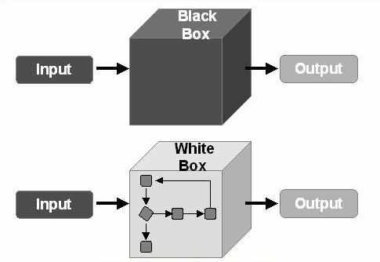

**[Figure 15–Testing Methods]**

# CONCLUSION

It was a great experience to design and implement the health Related app by using Flutter to work on its documentation. While working on this project we have learned many things especially how to apply the concept of Flutter in modelling of real world system. This project is developed using Dart, json, Firebase fully meets the objective of the system which it has been developed. This project is used for computerizing for Health related app for managing the healthy life. This software keeps all your basic vitals and plots graph according to the vitals and show how your health are evolves and give suggestion from your evolution.

# BIBLIOGRAPHY

## BOOK REFERENCE

1. Dart Apprentice: Beyond the Basics Authors: Jonathan Sande
2. Data Structures & Algorithms in Dart Author: Jonathan Sande, Vincent Ngo and Kelvin Lau
3. Flutter Apps Development: Build Cross-Platform Flutter Apps with Trust Author : Mouaz M. Al-Shahmeh
4. Beginning App Development with Flutter Author : Rap Payne

## WEB REFFERENCE

1. Pub.dev

Link: [*https://pub.dev/*](https://pub.dev/)

1. Dart programming language

Link: *https://dart.dev/*

1. Flutter

Link: *https://flutter.dev/*

1. Stack Overflow

Link: *https://stackoverflow.com/*